Augmenting Synthetic Images Richness with GANs
Marc Fiammante Oktal-SE scientific advisor, February 20th 2022.
Getting enough real image data representing all possible situations is a challenge for training computing vision algorithms. The required metrics for a proper training exceeds hundreds of thousands and even millions of images. They also all have to be labeled and categorized which is often not humanly feasible. In a recent article Gartner Maverick Research stated: Forget About Your Real Data Synthetic Data Is the Future of AI , however synthetic images even when generated by physical law computation of waves propagation may lack richness as the 3D models representing the landscape may miss the real world variability.
In this article I am using the word richness instead of entropy because entropy has a formal mathematical definition, and the approach described below has effects that are not solely focused on that entropy measure.
Generative Adverserial Networks is a well known technique that generates new images with feature statistics similar to the training set, however source feature information is not based on physics law computation of wave propagation, and thus may induce learning errors. This particularly happens on non humanly perceptible characteristics such as color relative variations under a few percents, or other wave ranges such as infrared, radar, or global navigation satellite system wave images.
Picture to picture GANs can create new pictures from a source picture and have been used to create photo-realistic realistic images from semantic label maps such as Nvidia's high definition pix2pix or as described in the article “How to Develop a Pix2Pix GAN for Image-to-Image Translation” that shows how to create that uses Google maps image-to-image translation dataset. (which I refer to as “Pix2Pix HowTo” in the rest of the article).
In my case I needed to take synthetic images as source and process them with a GAN to add realistic richness not affecting the overall image structure but only augmenting short range richness.
As starting code GAN I reused the one from the “Pix2Pix HowTo” article mentionned above.
There are two issues to solve with my problem compared to the tutorial:
- It is using small images with only 256×256 pixels while we need bigger images. Bigger images require more GPU memory, such as the Nvidia pix2pixhd example above that requires a GPU with 24G memory. In my case I want larger images and need to try training on a smaller GPU that has only 4GB.
- There is no training set for augmenting image richness and we need a few thousands of pairs of low richness/high richness image
Let me now explain the approach I used to handle both issues.

Using larger images
Evaluating the GPU memory required by a given model is not an easy task, however it is directly influenced by the number of trainable parameters, the size of the input, and the size of the data that is propagated between layers. Specifically on a convolution layer the number of convolutions and the strides which defines the displacement between two neighbouring convolutions influence the required amount of memory. In consequence to use larger images we need to have less convolutions and bigger strides.
Another factor that influences the memory is the number of layers, so we also need to reduce the number of layers. Each layer of an encoder increases the rectangle input zone called the “receptive field ” which Google research defines as the size of the region in the input that produces the feature. . That receptive field is computed from the convolution kernel size and the strides. A convolution reaches at a distance from the center pixel and the stride moves the next convolution away at a given distance.
The “Pix2Pix HowTo” receptive field size for the discriminator that has 6 convolution layers is 142x142 pixels and the encoder with 7 layers has a receptive field size of 190x190 pixels (see article “How to Implement Pix2Pix GAN Models From Scratch With Keras” for simple computation formula.
We also need to compute the size of the region in the input without padding that produces the features in the encoder of the U-Net as the image dimensions need to be a factor of this size, so that the decoder part can be compiled without errors. Rounding happen on encoder layer input/output sizes which values have to match the corresponding U-Net decoder part that tries to concatenate the output of the corresponding decoder layer and the output of the previous decoder layer. That size is only affected by the strides of convolution layers or pooling layers.
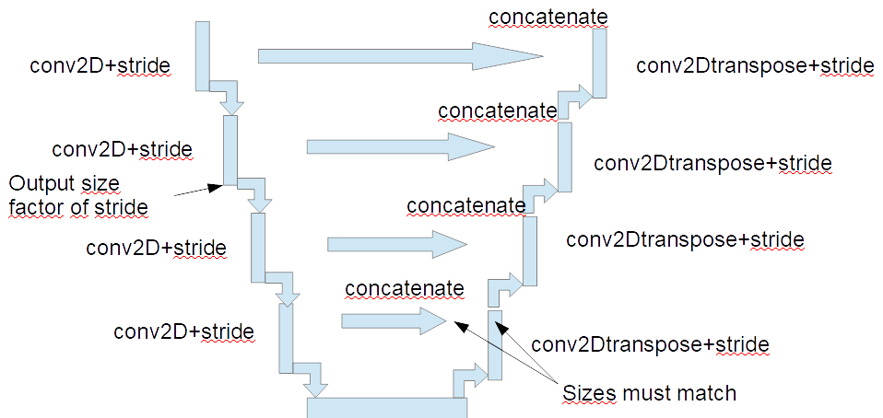
The following code snippets show how to compute the stride span for the encoder of a U-Net encoder-decoder to ensure that the concatenation has identical sizes between corresponding encoder layer and previous Conv2DTranspose output..
# simple calculation of the effective span zone per layer
def stride_span(output_size_from_previous_layer, stride_size):
return (output_size ) * stride_size

In our richness augmentation case we do not need to look 142 or 190 pixels away from a given source image pixel as the “Pix2Pix HowTo” does . After some iterations to find the best compromise the final selection is 5 layers for both the discriminator and the encoder with the following convolution kernel size and stride size giving a receptive field size of 100x100 and a span of 96x96 pixels.
- Kernel [2,2], stride [1,1]
- Kernel [3,3], stride [2,2]
- Kernel [4,4], stride [3,3]
- Kernel [4,4], stride [4,4]
- Kernel [4,4], stride [4,4]
The decoder model uses the same convolution kernels and strides in a reverse order.
# initialize the sequence convolution kernel and stride array
convstride=np.array([[[2,2],[1,1]],[[3,3],[2,2]],[[4,4],[3,3]],[[4,4],[4,4]],[[4,4],[4,4]]])

# for each layer of encoder or discriminator get the convolution
# kernel and stride for the next layer (FIFO)
(conv,stride),convstride=convstride[0,:,:],convstride[1:,:,:]

# for each layer of decoder get the convolution
# kernel and stride for the next layer in the reverse order (LIFO)
(conv,stride),convstrideg=convstrideg[-1,:,:],convstrideg[:-1,:,:]

Creating the low to high richness training set
There is no such training set of low richness/realistic image pairs. In addition we need a set which image size is a multiple of the stride span resulting from the encoder layers of the U-Net.
Given the 96 pixels stride span we selected images with a width of 96*10=960 by a height of 96*7=672, larger images resulting in an out of memory GPU error.
For the test purpose I selected 73 source images that were licence free real landscape images with a mix of desertic, countryside, forest, city, roads etc. These images were taken from https://commons.wikimedia.org/wiki/Category:Images with a size bigger than the 960x672 input size above, allowing us to create multiple training pairs from a single image by clipping different 960x672 zones from the source image.
Now the training requires as input a pair of reduced richness image and full richness image image.
The approach taken for creating reduced richness images from the full richness real images is to perform a K-Means to reduce the number of colors to 32 using OpenCV

#
import cv2
import numpy as np

def reduce_richness(img):
Z = img.reshape((-1,3))
# convert to np.float32
Z = np.float32(Z)
# define criteria, number of clusters(K) and apply kmeans()
criteria = (cv2.TERM_CRITERIA_EPS + cv2.TERM_CRITERIA_MAX_ITER, 10, 1.0)
K = 32 # number of colors
ret,label,center=cv2.kmeans(Z,K,None,criteria,10,cv2.KMEANS_RANDOM_CENTERS)
# Now convert back into uint8, and make original image
center = np.uint8(center)
res = center[label.flatten()]
res2 = res.reshape((img.shape))
return res2

Then by shifting 255 pixels and clipping these images were split in 4,286 pair of reduced richness and full richness images using the following code

verticalshift = 255
horizontalshift = 255
# image size as a factor of stride span
w=16*60
h=16*42
for y in range(0,imgheight-h,verticalshift):
for x in range(0, imgwidth-w+1, horizontalshift):
source_tile = im[y:y+h,x:x+w]
reduced_tile = reduced[y:y+h,x:x+w]
cv2.imwrite( originalpath(x,y) ,source_tile)
cv2.imwrite( reducedpath(x,y) ,reduced_tile)

After training 30,000 steps the model is used to transform the below test synthetic image(not part of in the training set). The number of colors grows from 57128 to 107,628 and the resulting color scatter as shown on the following page.
Original synthetic image
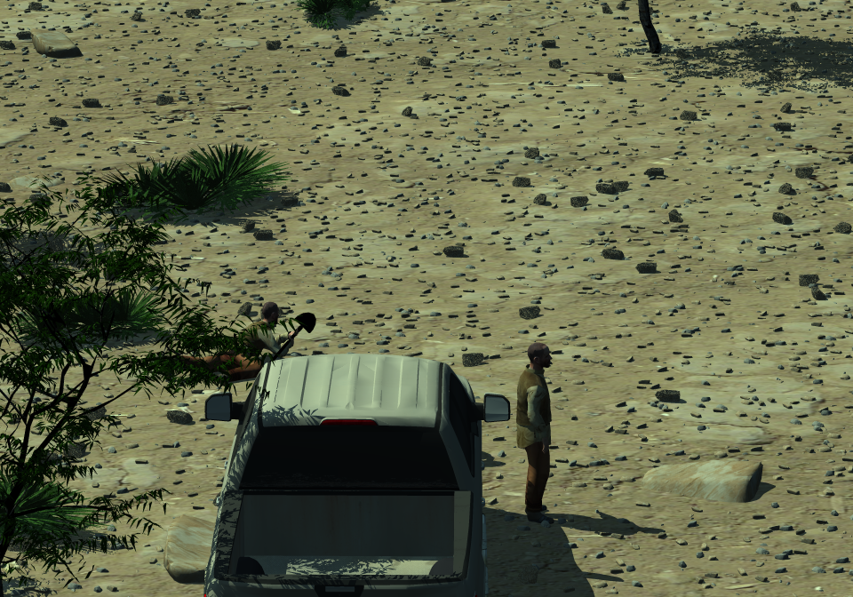
Generated image
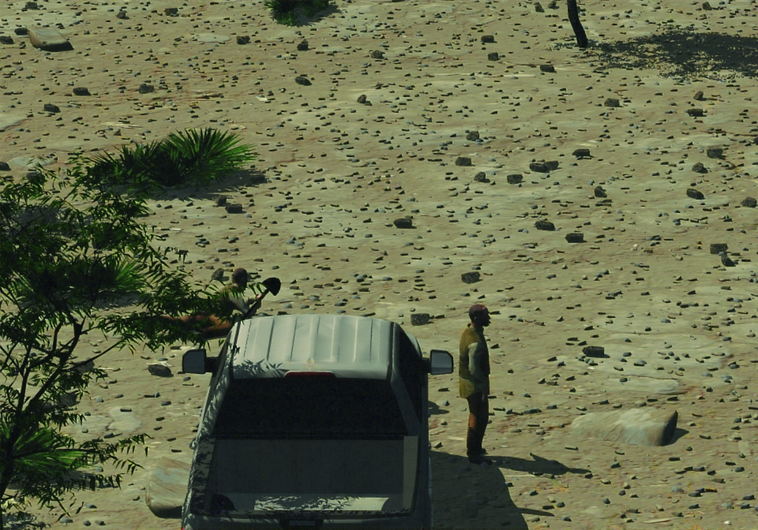

Here is the code to count unique colors and show their scattering in 3D (blue, green, red axis).

unique, counts = np.unique(img.reshape(-1, img.shape[-1]), axis=0, \
return_counts=True)
ax = plt.axes(projection = '3d')
x = [];y = [];z = [];c = [];s = []
for i,col in enumerate(unique):
x.append(col[0]);y.append(col[1]);z.append(col[2])
c.append((col[0] / 255, col[1] / 255, col[2] / 255))
s.append(counts[i]/10)
s.append(counts[i]/10)
ax.scatter(x,y,z, c = c,s=s)
The size of the circles is proportional to the number of colors with that particular color, and a few of these bigger circle appear, which indicates a concentration of some colors.
Original synthetic image color scatter.
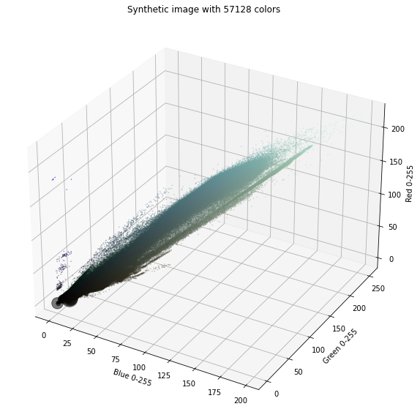
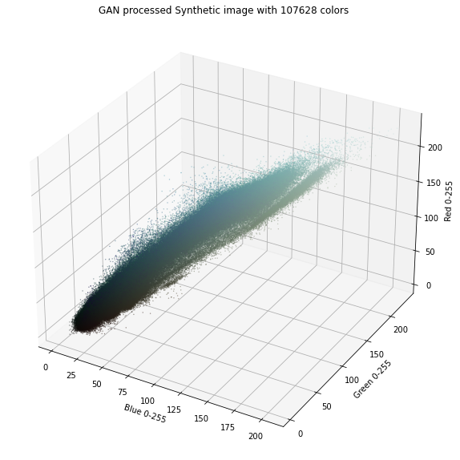
After processing by the GAN the scattering is better, and concentration of colors disappears.
Here I also show the results of a test performed with an image of the training set where colors grows from 32 to 148,643. The example K-Meaned source image that only has 32 colors
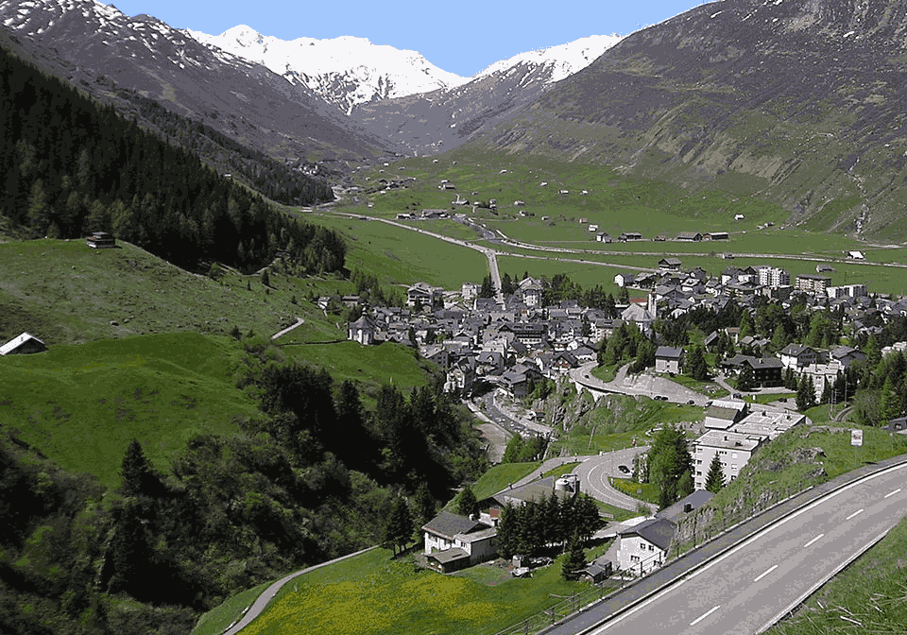
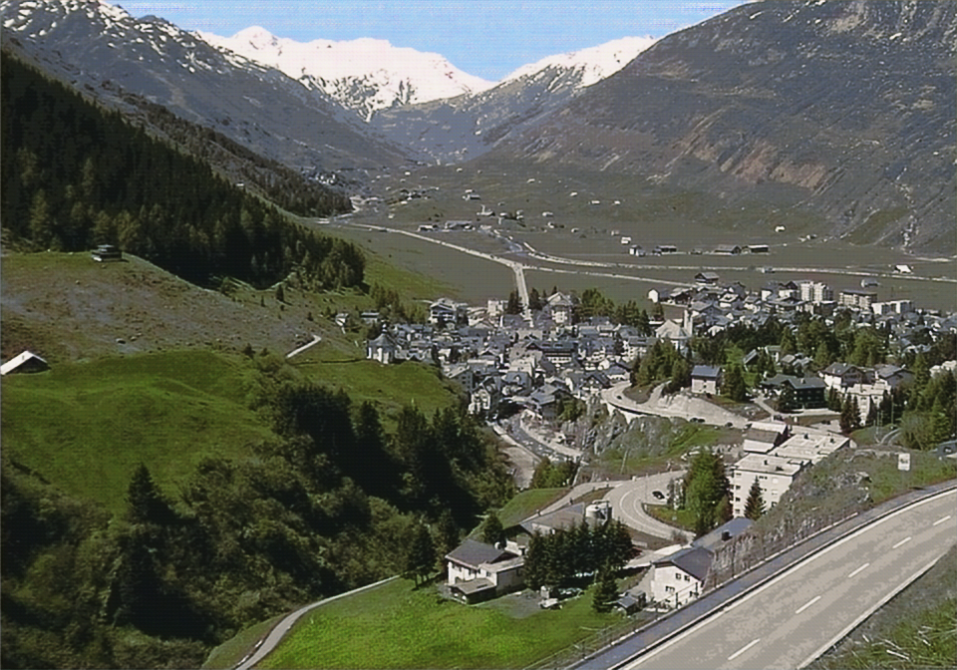
GAN Generated image from example source image has 148,643 colors.

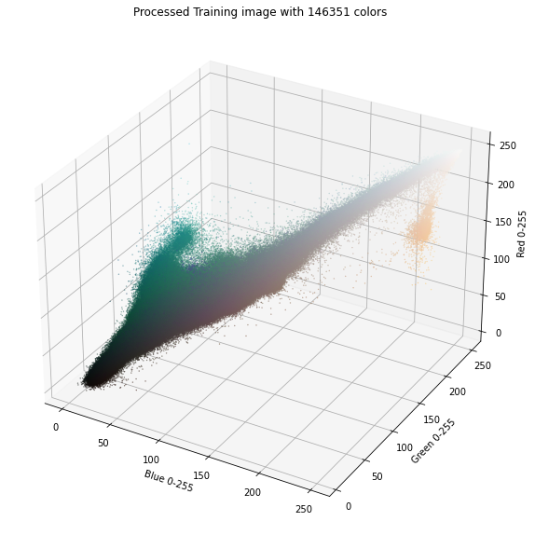
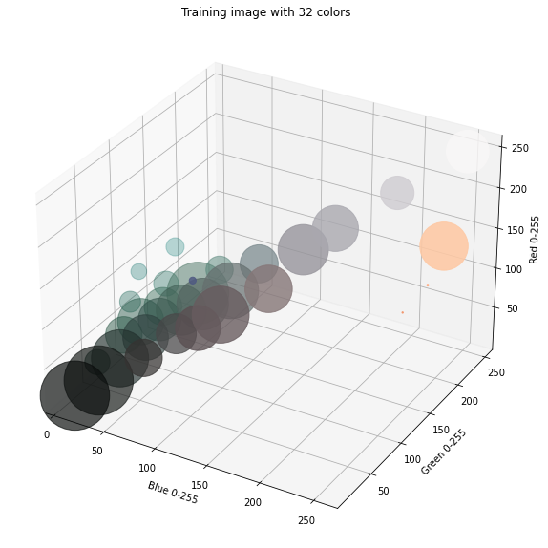
Here is the 3D visualisation of the color scattering for the training set image and the transformed image. The size of the circles is proportional to the number of colors with that particular color. As one can see, the image processing results in a cloud of colors expanding from the K Means centers.
Reduced color image color scatter

Same image color scatter after GAN processing

Conclusion
It took some iteration to find the working combination of layers, kernel and stride size with which the processing can happen on a 4GB GPU without out of memory errors.
To avoid pixellisation on synthetic images it ended being necessary to have an identical encoding layering between the discriminator and the U-Net encoder, with the first layer with a small (2,2) convolution kernel. Other attempts resulted in pixellisation on synthetic surfaces that shown some regular patterns when zooming.
In conclusion a GAN can effectively be used for augmenting synthetic image richness, the challenge remaining having enough training images. The K-Means richness reduction approach works effectively, even though it could be completed or replaced by other approaches such as Gaussian Mixture Model, bi lateral filtering, smoothing etc.

https://www.gartner.com/en/documents/4002912
https://scikit-image.org/docs/dev/auto_examples/filters/plot_entropy.html
https://github.com/NVIDIA/pix2pixHD
https://machinelearningmastery.com/how-to-develop-a-pix2pix-gan-for-image-to-image-translation/
https://machinelearningmastery.com/how-to-implement-pix2pix-gan-models-from-scratch-with-keras/

